Create Object On Your Own
Your task is to create a calculator to determine how long it will take to pay off a compound interest loan with systematic payments. Your webpage will take four inputs as follows:
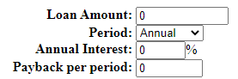
There are four allowable periods:
- Annual: Payment and Interest paid once a year
- Biannual: Payment and Interest paid every half year
- Quarterly: Payment and Interest paid four times a year
- Monthly: Payment and Interest paid once a month
The interest is calculated as annual interest/period. So an annual interest of 5% is paid as 2.5% twice a year.
Once all the data is input, the system should automatically calculate the loan and show the calculation. If any data is blank, an error message should be produced.
The final answer given should always round the number of years to pay to the next year. Thus a loan amount of 10000 at 5% annual interest paid as $1000 per year should produce:
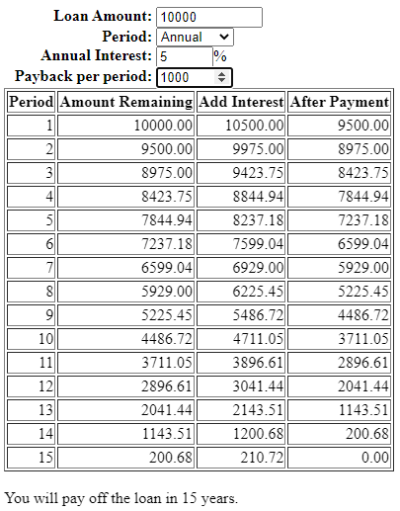
Paid quarterly, it should produce:
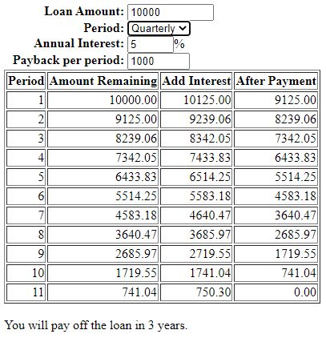
If the loan amount is 0 or blank, no calculation should be displayed.
The system should also test if the loan will never be paid back. If so, the system should say so.
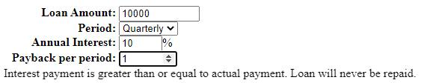
Marking:
Four input fields laid out correctly: 2 marks
System does not display table if loan amount is 0 or blank: 2 marks
System tests if loan is never paid back: 2 marks
System generates calculation table header: 2 marks
Calculation table has correct values: 2 marks
Amounts are displayed to two decimal places, but system keeps a precise count of amounts: 2 marks
System declares how many years it will take to pay back correctly: 2 marks
System begins calculation once sufficient information is available: 2 marks
No unusual behaviors: 4 marks

